C-AI311 – Deliverable #3 Design Report
Automated University Garage Management System (AUGMS)
Course: C-SW312: Introduction to Software Engineering
Semester: Fall 2025
Submission Date: December 27, 2025
Group Members: Aly Hassan, Mohamed Ehab, Alaa Shaaban, Kenzy Zedan, Shady Ashraf, Youssef Osama.

Abstract

This technical report documents our work for Deliverable #5 of the C-SW312 project. The deliverable focuses on object-oriented design driven by use cases. We build upon previous deliverables, including the use case diagram, system sequence diagrams (SSDs), activity diagrams, and domain model class diagram.

The report is divided into two main parts: Modelling and Implementation. In the Modelling Part, we selected core use cases, then classified them based on complexity, perform step-by-step diagrams for each, and developed a design class diagram and a package diagram. In the Implementation Part, we transform the design into Java code using StarUML java tool, producing a walking skeleton with a three-layered architecture.

1. Introduction

1.1 Project Overview
The Automated University Garage Management System (AUGMS) is a software solution designed to streamline parking operations at a university campus. It handles vehicle registration, entry and exit validation, occupancy monitoring, user access management, service requests (e.g., EV charging, cleaning), sensor error alerts, reporting, and more. The system integrates hardware components like sensors, gates, and displays with software layers for user interaction, business logic, and data persistence. Key stakeholders include students/faculty (parking users), garage admins, university managers, and system sensors.
The objectives of AUGMS are to:
- Automate vehicle entry/exit to reduce manual intervention.
- Provide real-time occupancy monitoring and alerts.
- Manage user registrations, access, and service requests efficiently.
- Generate reports for usage analysis and error logging.
- Ensure security, reliability, and scalability.

1.2 Assumptions
- The system uses a three-layered architecture: View (presentation), Controller (logic mediation), and Domain/Data (business logic and persistence).
- All use cases assume a relational database for persistence, with DAOs handling CRUD operations.
- User authentication is required for admin and manager actions; we assume a basic credential validation mechanism.
- Real-time updates (e.g., occupancy) use push notifications or polling; we assume reliable network connectivity.
- Fees for services are calculated based on type; exact formulas are simplified
- The domain model from previous deliverables includes core classes like ParkingUser, Vehicle, ParkingGarage, ParkingSpot, etc.

1.3 Rationale for Design Approach
Our design is use-case driven, ensuring traceability from analysis to design. We prioritize separation of concerns, low coupling, and high cohesion. The first-cut DCD starts from the domain model, adding controllers and view classes. Techniques like CRC help identify responsibilities collaboratively, while diagrams visualize interactions.

2. Classification of Use Cases
Based on the use case diagram from prior deliverables, we classified use cases by complexity:
- Simple: Involve basic operations with minimal branching or layers (e.g., data retrieval/update with little validation).
  - UC-104: View Parking Status
  - UC-106: Register User Account
  - UC-107: Update Vehicle Details
  - UC-503: Generate Sensor Error Alert
- Moderate: Require coordination across layers with some validation and alternatives.
  - UC-101: Register Vehicle
  - UC-103: Process Vehicle Exit
  - UC-302: Manage User Access
  - UC-201: Manage Vehicle Registration
- Complex: Involve multiple actors, conditional flows, real-time elements, or integrations (e.g., payments, sensors).
  - UC-102: Validate Vehicle Entry
  - UC-105: Request Service
  - UC-202: Monitor Garage Occupancy
  - UC-501: Generate Usage Report (assumed complex due to data aggregation)
Rationale: Classification considers interaction count, alternatives, and layer involvement. We selected core use cases representing system functionality.

3. Use Case Realization

3.1 Simple Use Cases

3.1.1 UC-104: View Parking Status
Description: Users view current parking spot statuses, counts.
Step-by-Step First-Cut DCD Partition:
- Start with domain classes: ParkingGarage, ParkingSpot, OccupancySensor.
- Add view class: ParkingStatusView (handles display).
- Add controller: ParkingStatusController (mediates requests).
- Add data access: ParkingSpotDAO, OccupancySensorDAO.
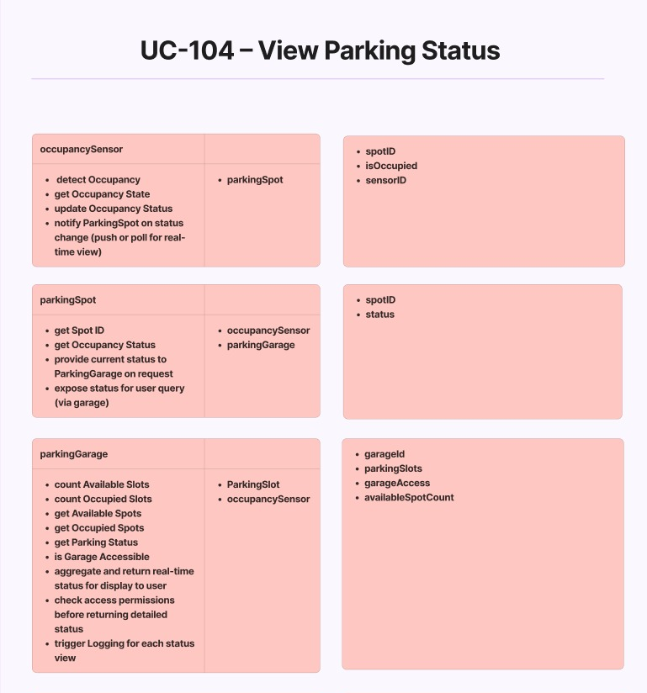
- Identify associations: ParkingGarage aggregates ParkingSpot; ParkingSpot links to OccupancySensor.

CRC Technique:
- occupancySensor: Responsibilities - detect Occupancy, get Occupancy State, update Occupancy Status, notify ParkingSpot on status change (push or pull for real-time view). Collaborators - parkingSpot.
- parkingSpot: Responsibilities - get Spot ID, provide Current Status to ParkingGarage on request, expose status for user query (via garage). Collaborators - occupancySensor, parkingGarage.
- parkingGarage: Responsibilities - count Available Slots, count Occupied Slots, get Available Spots, get Occupied Spots, is Garage Accessible, aggregate and return real-time status for display to user, check access permissions before returning detailed status. Collaborators - ParkingSpot, occupancySensor.
Rationale: CRC identifies clear responsibilities, assuming real-time polling for status.
Added methods: getSpotID(), isOccupied(), sensorID() to classes.

3.1.2 UC-106: Register User Account
Description: Users register accounts with personal details.
Step-by-Step First-Cut DCD Partition:
- Domain: User (Student/Faculty), GarageSystem.
- View: UserRegistrationView.
- Controller: RegistrationController.
- Data: ParkingUserDAO.
- Associations: User links to GarageSystem.
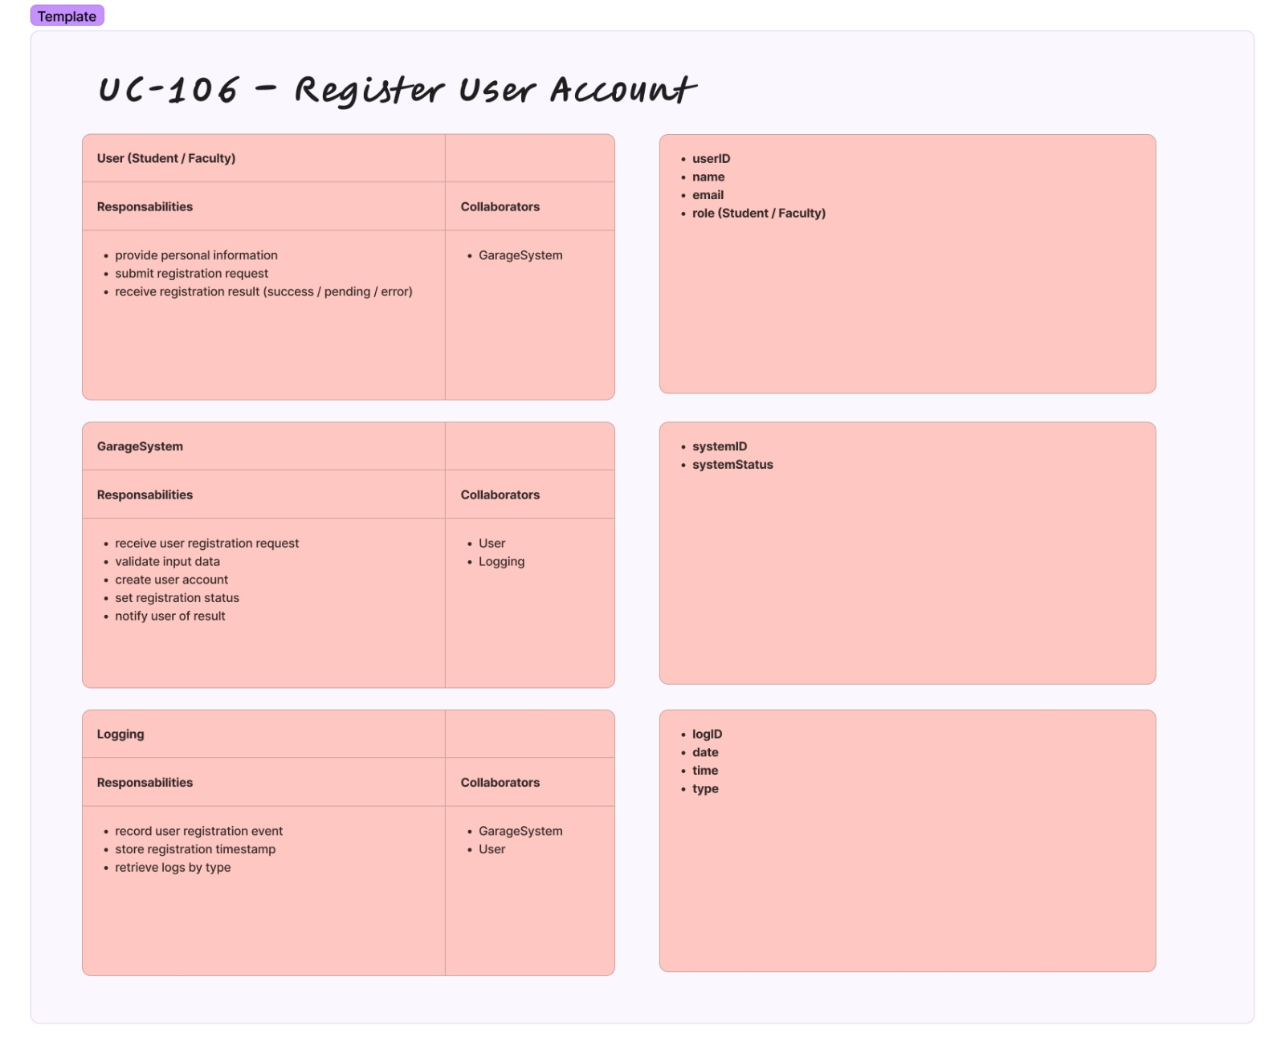
CRC Technique:
- User (Student/Faculty): Responsibilities - provide personal information, submit registration request, receive registration result (success/pending/error). Collaborators - GarageSystem.
- GarageSystem: Responsibilities - receive user registration request, validate input data, create user account, set registration status, notify user of result. Collaborators - User, Logging.
- Logging: Responsibilities - record user registration event, store registration timestamp, retrieve logs by type. Collaborators - GarageSystem, User.
Rationale: Simple validation assumed (e.g., unique email); no complex approvals.
Added: userID, name, email, role. Methods: createUserAccount(), validateInputData().

3.1.3 UC-503: Generate Sensor Error Alert
Description: System generates alerts for sensor faults.
Step-by-Step First-Cut DCD Partition:
- Domain: Sensor, OccupancySensor, GateSensor, GarageAdmin, UniversityManager, Logging.
- View: SensorAlertView.
- Controller: SensorAlertController.
- Data: SensorDAO, OccupancySensorDAO, GateSensorDAO.
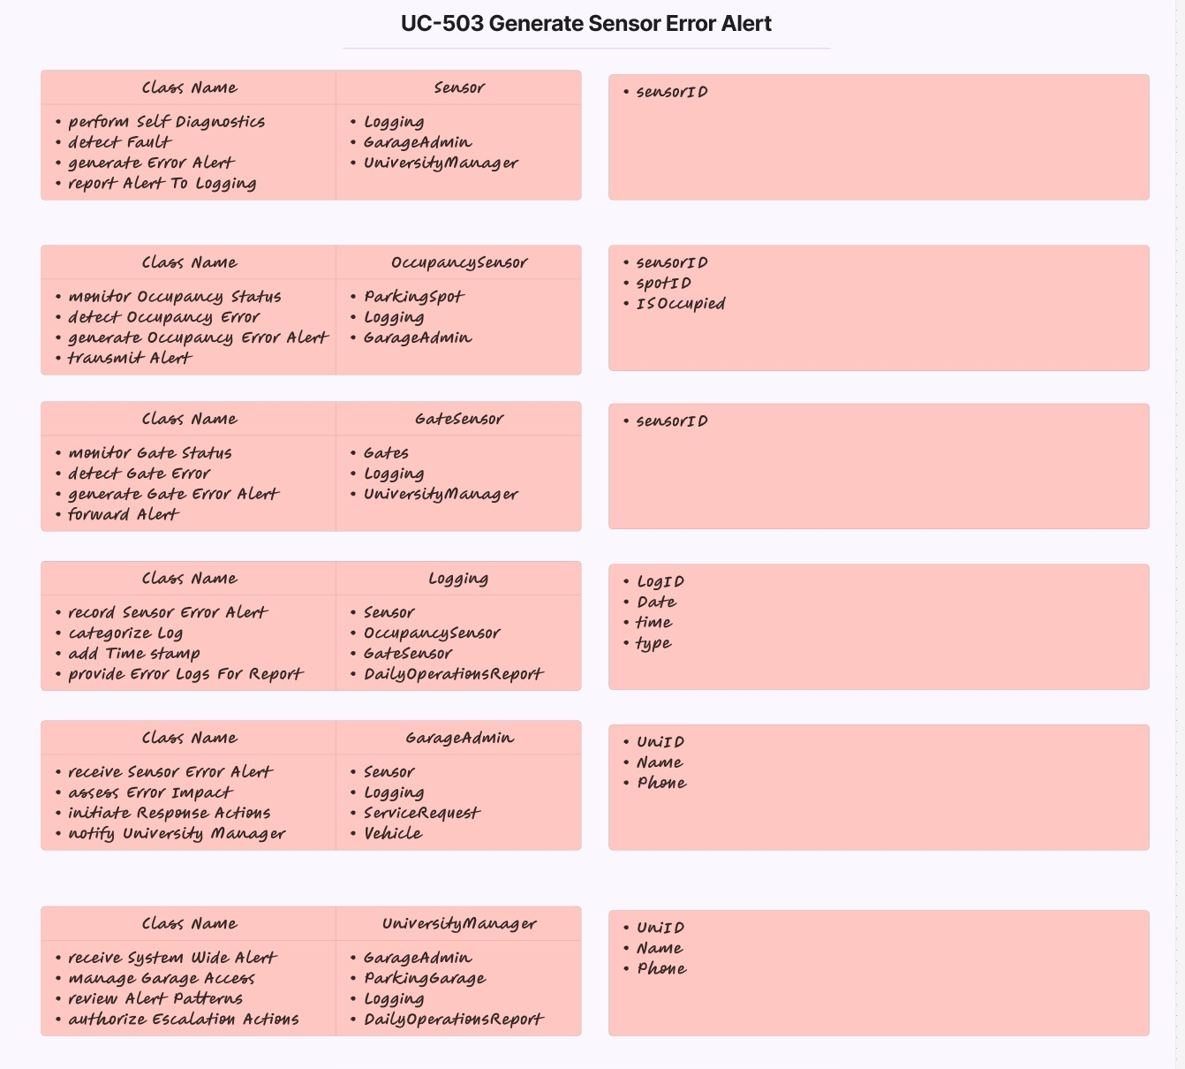
- Associations: Sensors link to Logging and Admins.

CRC Technique:
- Sensor: Responsibilities - perform Self Diagnostics, detect Fault, generate Error Alert, report Alert To Logging. Collaborators - GarageAdmin, UniversityManager.
- OccupancySensor: Responsibilities - monitor Occupancy Status, detect Occupancy Error, transmit Occupancy Error Alert. Collaborators - ParkingSpot, Logging, GarageAdmin.
- GateSensor: Responsibilities - monitor Gate Status, detect Gate Error, forward Gate Error Alert. Collaborators - Logging, UniversityManager.
- Logging: Responsibilities - record Sensor Error Alert, categorize Log, add Time Stamp, provide Error Logs For Report. Collaborators - Sensor, OccupancySensor, GateSensor.
- GarageAdmin: Responsibilities - receive Sensor Error Alert, assess Error Impact, initiate Response Actions, notify University Manager. Collaborators - Sensor, Logging.
- UniversityManager: Responsibilities - receive System Wide Alert, manage Garage Access, review Alert Patterns, authorize Escalation Actions. Collaborators - GarageAdmin, Logging.
Rationale: Assumes automatic fault detection; alerts via view layer.
Added: sensorID, spotID, isOccupied. Methods: detectFault(), generateAlert().

3.1.4 UC-107: Update Vehicle Details
Description: Users update vehicle info like plate, model.
Step-by-Step First-Cut DCD Partition:
- Domain: Vehicle, Logging.
- View: VehicleUpdateView.
- Controller: VehicleUpdateController.
- Data: VehicleDAO.
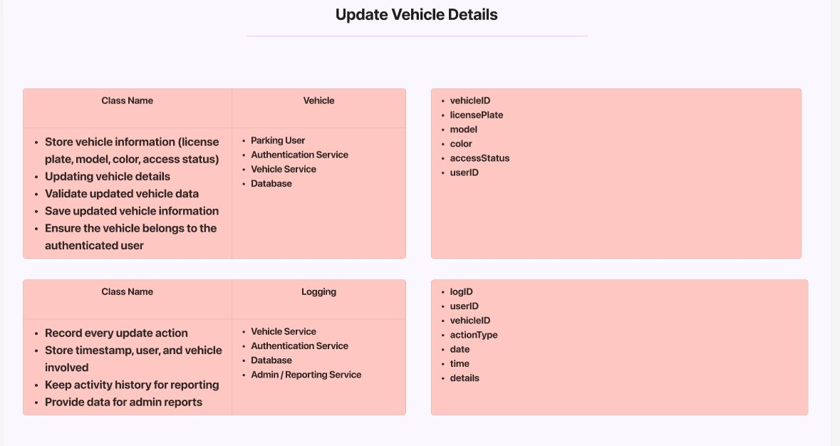
- Associations: Vehicle links to ParkingUser.
CRC Technique:
- Vehicle: Responsibilities - store vehicle information (license plate, model, color, access status), update vehicle details, validate updated vehicle data, save updated vehicle information, ensure the vehicle belongs to the authenticated user. Collaborators - Parking User, Authentication Service, Vehicle Service, Database.
- Logging: Responsibilities - record every update action, store timestamp, user, and vehicle involved, keep activity history for reporting, provide data for admin reports. Collaborators - Vehicle Service, Authentication Service, Database, Admin/Reporting Service.
Rationale: Authentication assumed to prevent unauthorized updates.
Added: vehicleID, licensePlate, model, color, accessStatus, userID. Methods: updateDetails(), validateData().

3.2 Moderate Use Cases

3.2.1 UC-101: Register Vehicle
Description: Users register vehicles with personal/vehicle details.
Step-by-Step First-Cut DCD Partition:
- Domain: ParkingUser, Vehicle, Logging.
- View: RegistrationView.
- Controller: RegistrationController.
- Data: ParkingUserDAO, VehicleDAO, LoggingDAO.
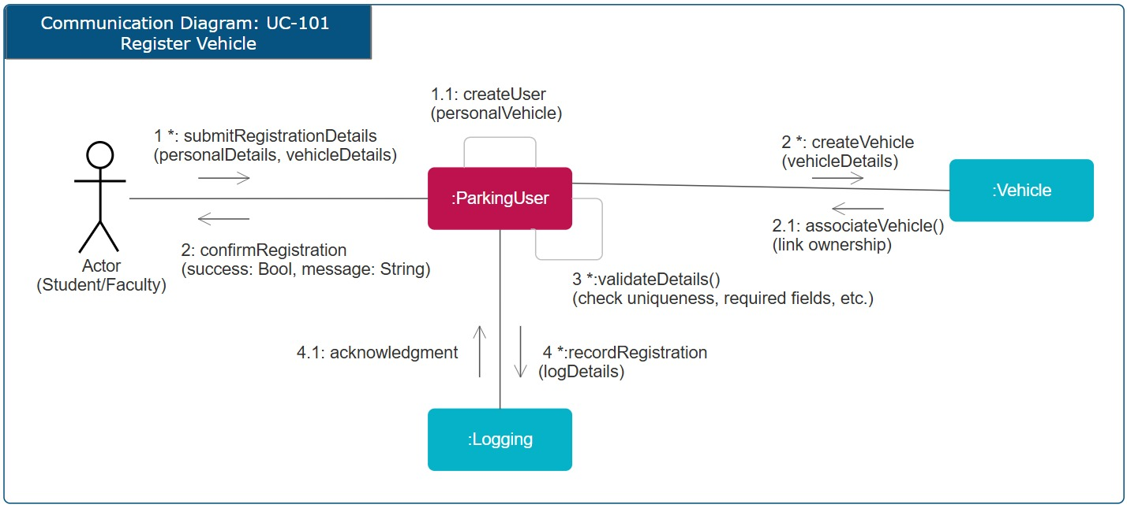
- Associations: ParkingUser owns Vehicle.

Multi-Layer Communication Diagram: The diagram shows: Actor (Student/Faculty) submits details to ParkingUser, which creates user and vehicle, validates uniqueness, records in Logging.
Rationale: Moderate due to validation and linking; assumes unique license plates.
Added methods: submitRegistrationDetails(), createUser(), createVehicle(), associateVehicle(), validateDetails(), recordRegistration().

3.2.2 UC-103: Process Vehicle Exit
Description: Validate exiting vehicle, calculate fee, update spot.
Step-by-Step First-Cut DCD Partition:
- Domain: GarageSystem, ExitSensor, GarageDB, ExitGate, Logging, OccupancySensor.
- View: VehicleExitView.
- Controller: VehicleExitController.
- Data: VehicleDAO, ParkingSpotDAO.
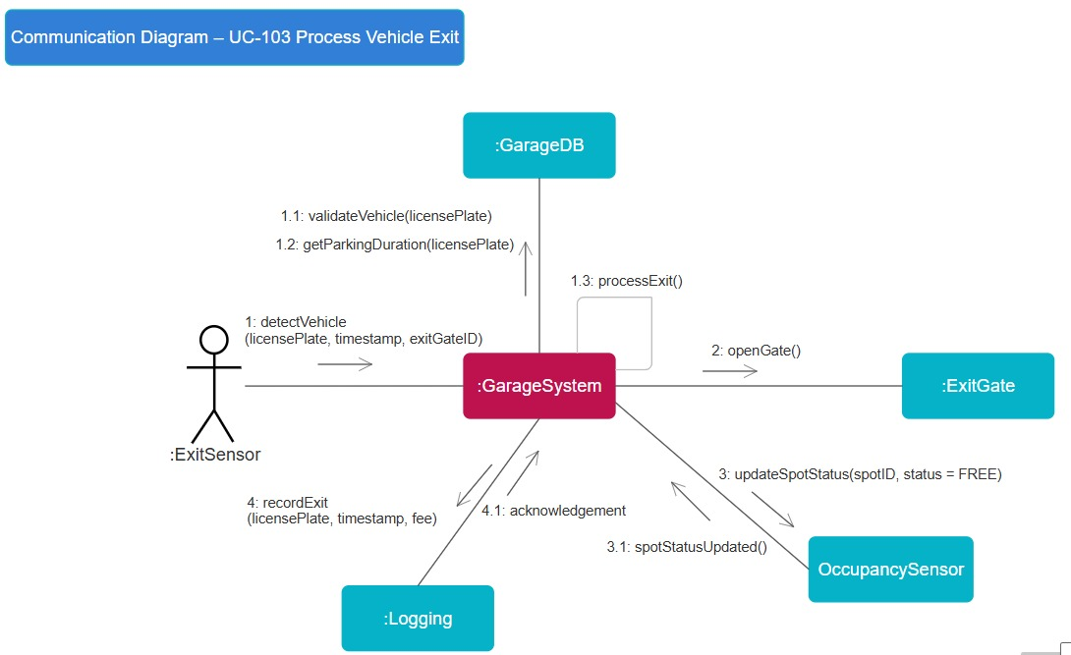
- Associations: ExitSensor detects Vehicle; GarageSystem processes.

Multi-Layer Communication Diagram: Diagram: ExitSensor detects vehicle, sends to GarageSystem, which validates, gets duration from GarageDB, processes exit, updates spot, opens gate, records in Logging.
Rationale: Assumes timestamp-based fee calculation; garage not full on exit.
Added: licensePlate, timestamp, exitGateID. Methods: detectVehicle(), validateVehicle(), getParkingDuration(), processExit(), updateSpotStatus(), recordExit().

3.2.3 UC-302: Manage User Access
Description: Admins change user access status.
Step-by-Step First-Cut DCD Partition:
- Domain: GarageAdmin, ParkingUser, Logging.
- View: UserAccessView.
- Controller: UserAccessController.
- Data: GarageAdminDAO, ParkingUserDAO.
- Associations: GarageAdmin updates ParkingUser.
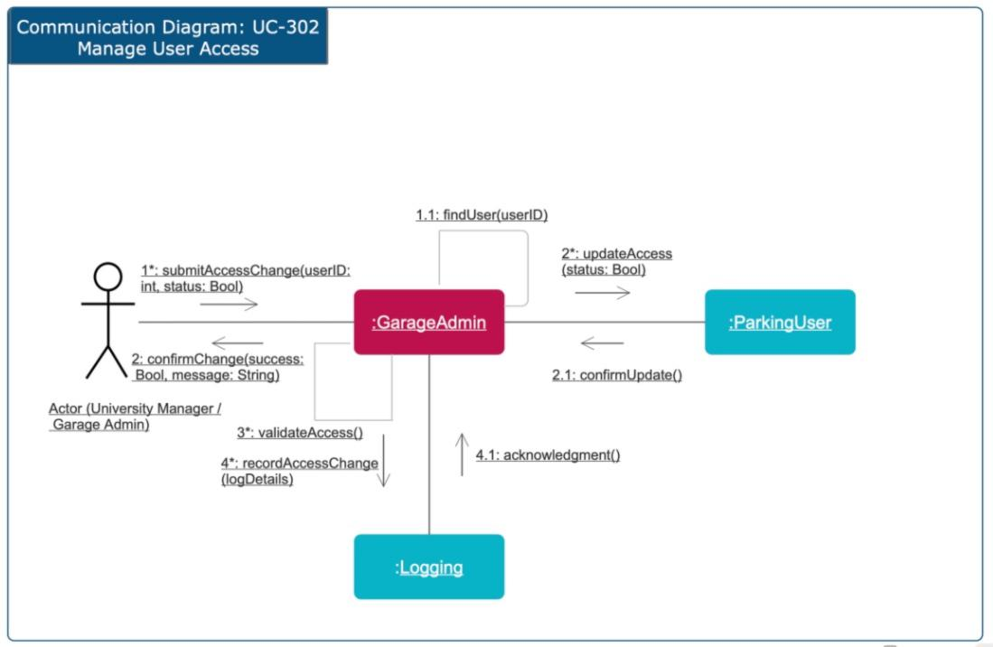
Multi-Layer Communication Diagram: Diagram: Actor (University Manager/Garage Admin) submits change, GarageAdmin finds user, updates access, confirms, validates, records in Logging.
Rationale: Boolean status for access; assumes admin authentication.
Added: userID, status (Bool). Methods: submitAccessChange(), findUser(), updateAccess(), confirmUpdate(), validateAccess(), recordAccessChange().

3.2.4 UC-202: Monitor Garage Occupancy
Description: Admins request live occupancy views.
Step-by-Step First-Cut DCD Partition:
- Domain: GarageApp, OccupancySensor, Display.
- View: ParkingStatusView.
- Controller: ParkingStatusController.
- Data: OccupancySensorDAO.
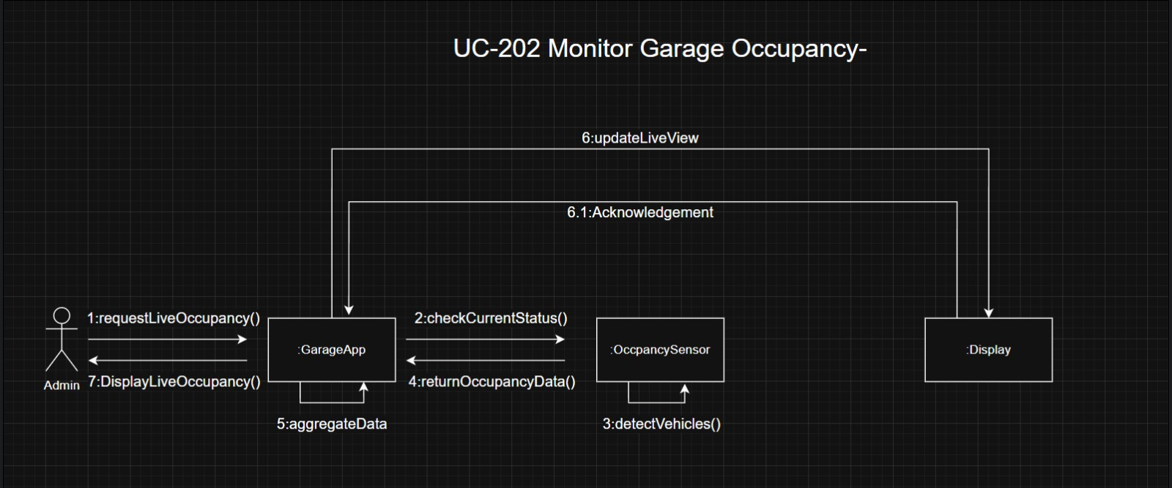
- Associations: GarageApp requests from Sensor.

Multi-Layer Sequence Diagram: Admin requests live, GarageApp checks status, Sensor detects vehicles, aggregates data, returns data, displays, updates view, acknowledgment.
Rationale: Real-time assumption via aggregation; display is external hardware.
Added: Methods: requestLiveOccupancy(), checkCurrentStatus(), detectVehicles(), aggregateData(), returnOccupancyData(), displayLiveOccupancy(), updateLiveView().

3.3 Complex Use Cases

3.3.1 UC-102: Validate Vehicle Entry
Description: Validate entering vehicle, check space, open gate.
Step-by-Step First-Cut DCD Partition:
- Domain: AUGMSSystem, GateSensor, EntryGate.
- View: VehicleEntryView.
- Controller: VehicleEntryController.
- Data: VehicleDAO, ParkingGarageDAO.
- Associations: GateSensor scans to AUGMSSystem.
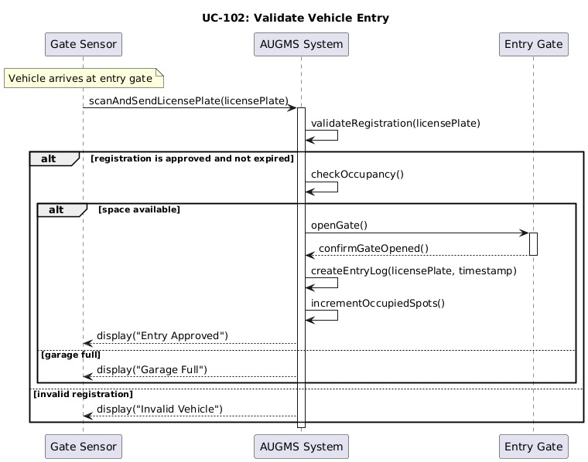
Multi-Layer Sequence Diagram: Vehicle arrives, GateSensor scans/sends plate, AUGMSSystem validates registration, checks occupancy, opens gate if space, creates log, increments occupied, displays status.
Rationale: Alternatives for invalid/full; assumes space check before entry.
Added: licensePlate. Methods: scanAndSendLicensePlate(), validateRegistration(), checkOccupancy(), openGate(), confirmGateOpened(), createEntryLog(), incrementOccupiedSpots().

3.3.2 UC-105: Request Service
Description: Users request spot-dependent services with payment.
Step-by-Step First-Cut DCD Partition:
- Domain: ParkingSpot, ServiceRequest, ParkingUser, Vehicle, Invoice, Payment, PaymentMethod, Logging.
- View: ServiceRequestView.
- Controller: ServiceRequestController.
- Data: ServiceRequestDAO, InvoiceDAO, PaymentDAO.
- Associations: ServiceRequest links to ParkingSpot, User, Vehicle, Invoice.
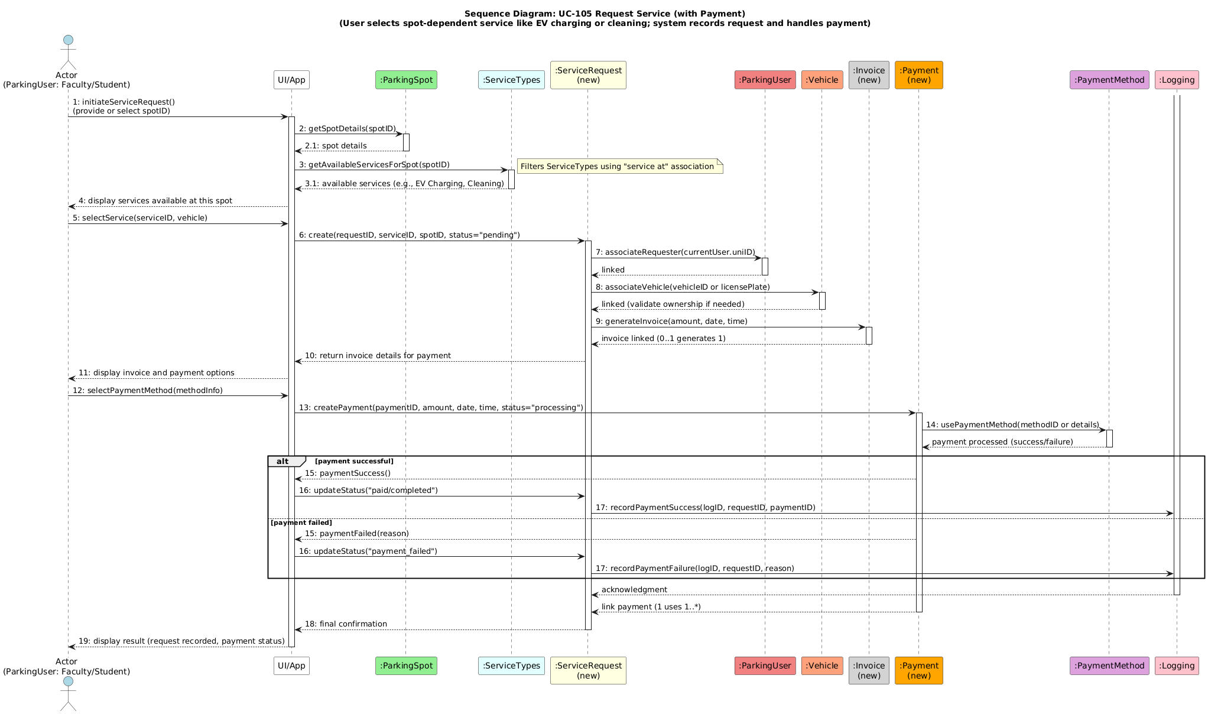
Multi-Layer Sequence Diagram: Actor initiates, gets details, available services, creates request, associates user/vehicle, generates invoice, displays payment, processes, records success/failure in Logging.
Rationale: Assumes service types (EV charging, cleaning); payment success updates status.
Added: spotID, serviceID, requestID, paymentID, amount, date, time. Methods: initiateServiceRequest(), getSpotDetails(), getAvailableServicesForSpot(), createRequest(), associateRequester(), associateVehicle(), generateInvoice(), createPayment(), usePaymentMethod(), recordPaymentSuccess/Failure().

3.3.3 UC-201: Manage Vehicle Registration
Description: Admins manage pending registrations.
Step-by-Step First-Cut DCD Partition:
- Domain: ParkingUser, GarageAdmin, AUGMSSystem, Logging.
- View: VehicleManagementView.
- Controller: VehicleManagementController.
- Data: ParkingUserDAO, VehicleDAO.
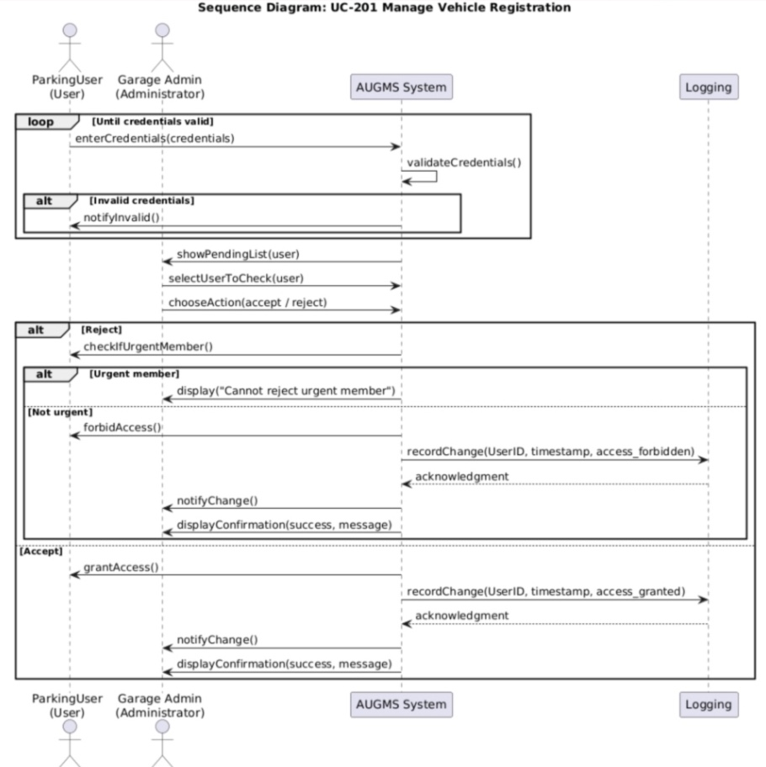
- Associations: GarageAdmin reviews ParkingUser.

Multi-Layer Communication Diagram: (Note: Provided as sequence, but adapted.) Loop for credentials, show pending, select action (accept/reject), check urgent, forbid/record, notify.
Rationale: Loop for multiple reviews; urgent members can't be rejected.
Added: credentials, userID, timestamp, access. Methods: validateCredentials(), showPendingList(), selectUserToCheck(), chooseAction(), checkIfUrgentMember(), recordChange(), notifyChange().

3.3.4 UC-301: Generate Usage Report
Description: Managers request usage reports.
Step-by-Step First-Cut DCD Partition:
- Domain: ReportUI, ReportController, ReportService, EntryExitRepository, ServiceLogRepository, ReportGenerator, Logs.
- View: ReportView.
- Controller: ReportController.
- Data: LogsDAO.
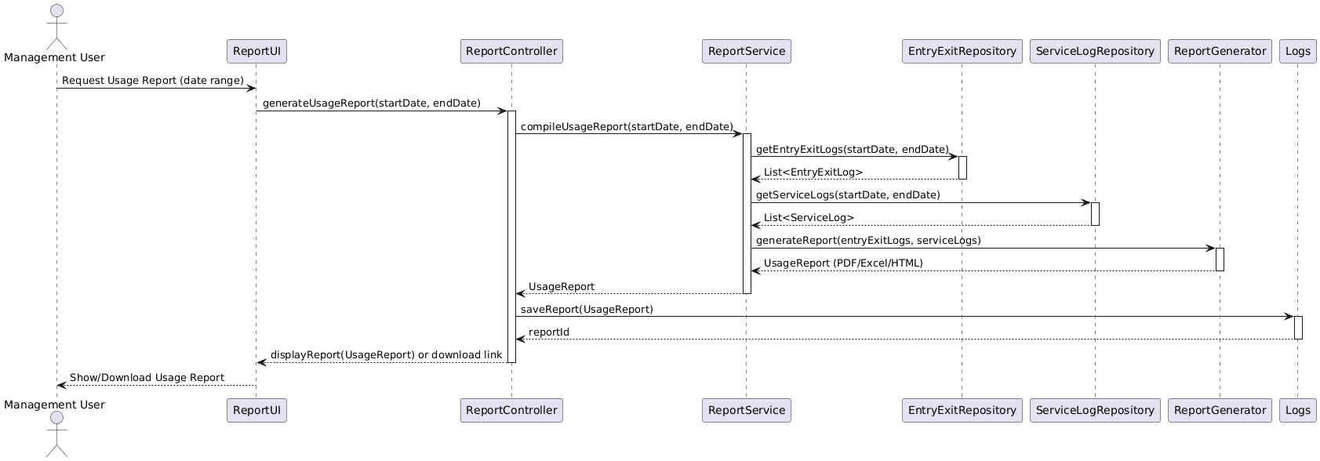
- Associations: ReportService aggregates logs.

Multi-Layer Sequence Diagram: Management User requests report (date range), Controller compiles, Service gets logs, generates report, saves, displays/downloads.
Rationale: Assumes PDF/Excel/HTML formats; date range filtering.
Added: startDate, endDate. Methods: requestUsageReport(), generateUsageReport(), compileUsageReport(), getEntryExitLogs(), getServiceLogs(), generateReport(), saveReport(), displayReport().

4. Complete Design Class Diagram
The final design class diagram integrates all updated partitions from the 12 use cases. It includes view, controller, service/domain, entity, and data layers with methods, attributes, and relationships (associations, inheritance, dependencies).
Rationale: Layered for MVC pattern; inheritance for sensors; DAOs for persistence. Assumptions: All entities have IDs; services handle business logic.

5. Package Diagram
The package diagram organizes the complete DCD into layers and subsystems for modularity.
- View Layer: RegistrationView, ParkingStatusView, etc.
- Controller Layer: RegistrationController, ParkingStatusController, etc.
- Domain Layer: ParkingUser, Vehicle, ParkingGarage, etc.
- Data Layer: ParkingUserDAO, VehicleDAO, etc.
- Entity: Sensor, Logging, etc.
- Service: UserRegistrationService, VehicleEntryService, etc.
Rationale: Packages reduce dependencies; e.g., View depends on Controller, which depends on Service/Domain. Assumptions: No cyclic dependencies; services can depend on each other for composition.

6. Final Architecture:
parking-system/
├── main.java
├── ApplicationConfig.java
│
├── presentation/
│ ├── RegistrationView.java
│ ├── ParkingStatusView.java
│ ├── ServiceRequestView.java
│ ├── VehicleManagementView.java
│ ├── UserAccessView.java
│ ├── VehicleUpdateView.java
│ ├── SensorAlertView.java
│ ├── ReportView.java
│ └── ManageServiceRequestView.java
│
├── controller/
│ ├── RegistrationController.java
│ ├── ParkingStatusController.java
│ ├── ServiceRequestController.java
│ ├── VehicleManagementController.java
│ ├── UserAccessController.java
│ ├── VehicleUpdateController.java
│ ├── SensorAlertController.java
│ ├── ReportController.java
│ └── ManageServiceRequestController.java
│
├── service/
│ ├── RegistrationService.java
│ ├── VehicleEntryService.java
│ ├── VehicleExitService.java
│ ├── ParkingStatusService.java
│ ├── ServiceRequestService.java
│ ├── VehicleManagementService.java
│ ├── UserAccessService.java
│ ├── VehicleUpdateService.java
│ ├── SensorAlertService.java
│ ├── ReportService.java
│ ├── InvoiceService.java
│ ├── PaymentService.java
│ ├── AuthenticationService.java
│ ├── LoggingService.java
│ ├── ReportGenerator.java
│ └── ManageServiceRequestService.java
│
├── dao/
│ ├── ParkingUserDAO.java
│ ├── VehicleDAO.java
│ ├── ParkingGarageDAO.java
│ ├── ParkingSpotDAO.java
│ ├── OccupancySensorDAO.java
│ ├── EntryGateDAO.java
│ ├── ExitGateDAO.java
│ ├── GateSensorDAO.java
│ ├── SensorDAO.java
│ ├── ServiceRequestDAO.java
│ ├── ServiceTypeDAO.java
│ ├── InvoiceDAO.java
│ ├── PaymentDAO.java
│ ├── PaymentMethodDAO.java
│ ├── GarageAdminDAO.java
│ ├── UniversityManagerDAO.java
│ ├── LoggingDAO.java
│ ├── EntryExitRepository.java
│ ├── ServiceLogRepository.java
│ └── ParkingStatusDAO.java
│
├── entity/
│ ├── ParkingUser.java
│ ├── Vehicle.java
│ ├── ParkingGarage.java
│ ├── ParkingSpot.java
│ ├── OccupancySensor.java
│ ├── Sensor.java
│ ├── GateSensor.java
│ ├── EntryGate.java
│ ├── ExitGate.java
│ ├── ServiceRequest.java
│ ├── ServiceType.java
│ ├── Invoice.java
│ ├── Payment.java
│ ├── PaymentMethod.java
│ ├── GarageAdmin.java
│ ├── UniversityManager.java
│ ├── Log.java
│ ├── EntryExitLog.java
│ ├── ServiceLog.java
│ ├── ErrorLog.java
│ ├── UsageReport.java
│ └── ParkingStatus.java
│
└── util/
├── enums/
├── exceptions/
└── helpers/

#. Conclusion
This report presents a comprehensive OO design for AUGMS, realizing 12 use cases through step-by-step DCDs, techniques, and updates. The design ensures the system is explanatory, modular, and aligned with requirements. All assumptions and rationales are documented for clarity. The UML project (zipped) accompanies this report.

